Day4:Online Task:

2.

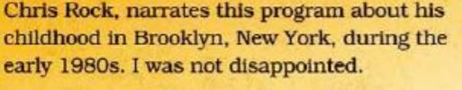

3.

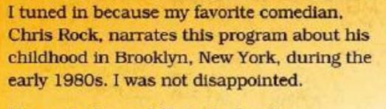

4.

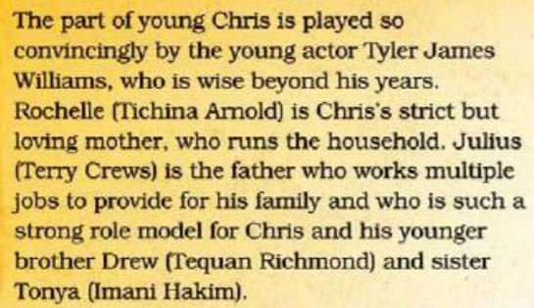

5.

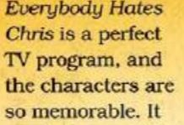

6.

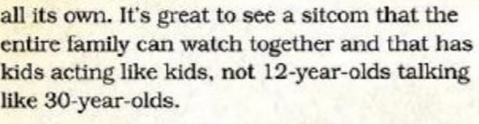

B.

1.Food factory is the title of the program and it is a Documentary on food facts

2.I want to watch this program as i am curious to know the making of favourite foods and technologies used in it.It is really an intriguing show

3.The program is about how different foods are made with different technologies and what gives the taste for the food we eat

4.John Hein is the anchor who takes us through the different products whose questions are intriguing

5.The show is worth watching as we can know about our favourite food and the intricate process applied for its production

6.I would definitely recommend the program to all food lovers who whish to know about the making of their food

B.

This Monday when i saw one of the episodes of the food factory in discovery ,about how the tortillas are made ,i just fell more in love with it

I just got tuned to the program as i was really interested in knowing how the complex machinery work in making my favourite food and what gets the taste to it

The anchor john hein adds flavour to the program by asking many interesting questions to the manufacturers which makes me go awe.

This is a perfect Tv show which every one would enjoy as people irrespective of their age are foodies.I would definitely suggest you to watch one with your family which clears all your mom’s doubt about the food you eat and probably you may get more of them. So don’t forget to watch this show tonight with your family